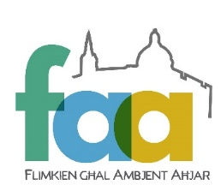
Flimkien għal Ambjent Aħjar is the NGO
fighting for your quality of life, urban and
rural heritage. Please help us to protect
your quality of life by becoming a member
of FAA or making a donation.Many thanks!

MEMBERSHIP FORM
Title |  | Name |  | Surname
Address
Email CAPS |  |  |  |  | Phone

Membership Category – please mark accordingly
Student Membership - 1 year- €10
Individual Membership - 1 year - €22
Family Membership (parents &children under 15) - 1 year - €35
Individual Membership - 5 year - €85
Individual Life Membership - €300
Donation | €
I would like to volunteer a little time to help FAA

Payment Method
Cheque (made payable to Flimkien għal Ambjent Aħjar)
Online at https//faa.org.mt/join/
Signature/Date
I give consent for FAA to use my personal details to inform me about its activities, events and campaigns, whilst prohibiting sharing my information with Third Parties.

FAA, 23, St Anne. Street, Floriana, Malta, FRN 9012
+356 79303259 | +356 20106428 | contact@faa.org.mt

